CRICKSTATS – SALESFORCE CAPSTONE PROJECT
PHASE 3 – PROJECT DESIGN
CRICKET PLAYER PERFORMANCE TRACKING APPLICATION
Information | Details
Project Title | CRICKET PLAYER PERFORMANCE TRACKING APPLICATION  CRICKSTATS
Project Domain | Cloud Computing / Salesforce Administration
Platform | Salesforce Lightning Developer Edition
Team Leader | Saravanan S - (Reg. No. 24134031802521044)
Member 2 | SRIVARSHAN S- (Reg. No. 24134031802521048)
Member 3 | Tamilselvan S- (Reg. No. 24134031802521051)
Member 4 | Karthi Karthi- (Reg. No. 24134031802521020)
Member 5 | Barathiraja R- (Reg. No. 24134031802521013)
Institution | PS PT MGR GOVERNMENT ARTS & SCIENCE COLLEGE, SIRKALI, PUTHUR-609108 (College Code: ANM403)
Submission Portal | SkillWallet / Naan Mudhalvan

1. Problem–Solution Fit
CRICKSTATS addresses manual records, data loss, scattered performance data and reporting delays through automated Salesforce data management, secure cloud storage, interactive dashboards and real-time reporting.
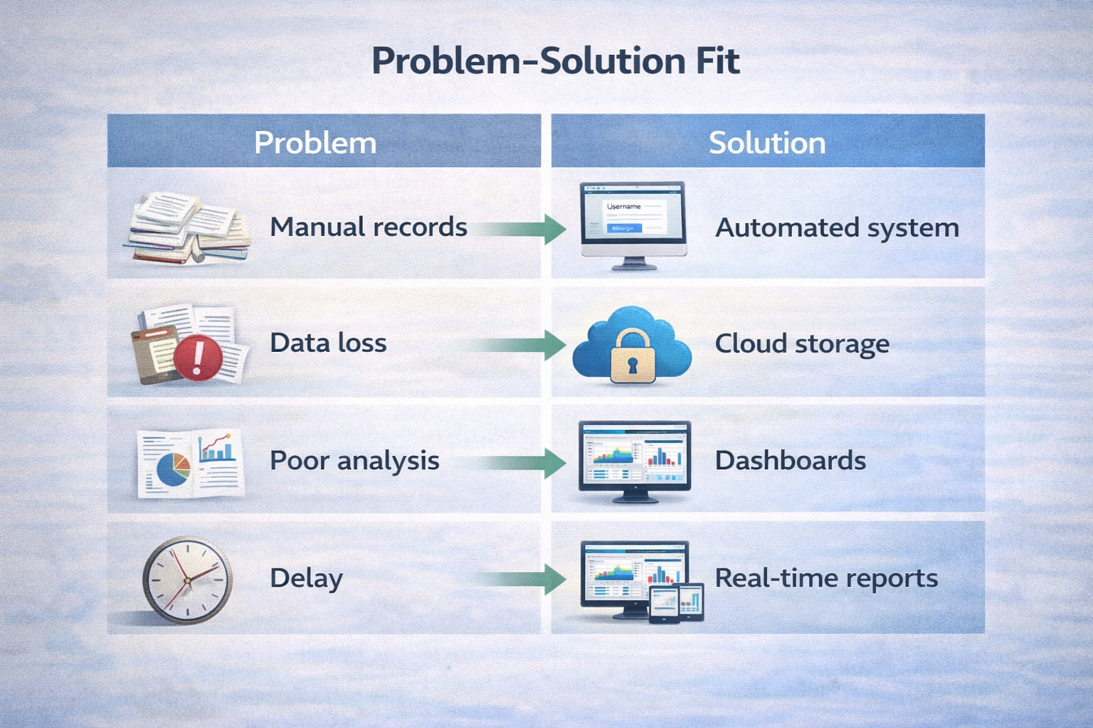

2. Proposed Solution
- Custom objects: Player and Match Performance
- Master-detail relationships
- Roll-up summaries
- Lightning App
- Automated flows
- Interactive dashboards

3. Key Features
- Centralized database
- Live statistics
- Secure access
- Scalable design
- Easy reporting

4. Solution Architecture
Layer | Components
Presentation Layer | Salesforce Lightning UI, Custom Apps, Custom Navigation Tabs and Page Layouts
Application Layer | Declarative Screen Flows, Input Validation Rules and Calculation Formulas
Data Layer | Player__c, Match_Performance__c, Master-Detail Relationships and Roll-up Summaries
Analytics Layer | Grouped Summary Reports, Screen Flow Data Tables and Interactive Dashboards

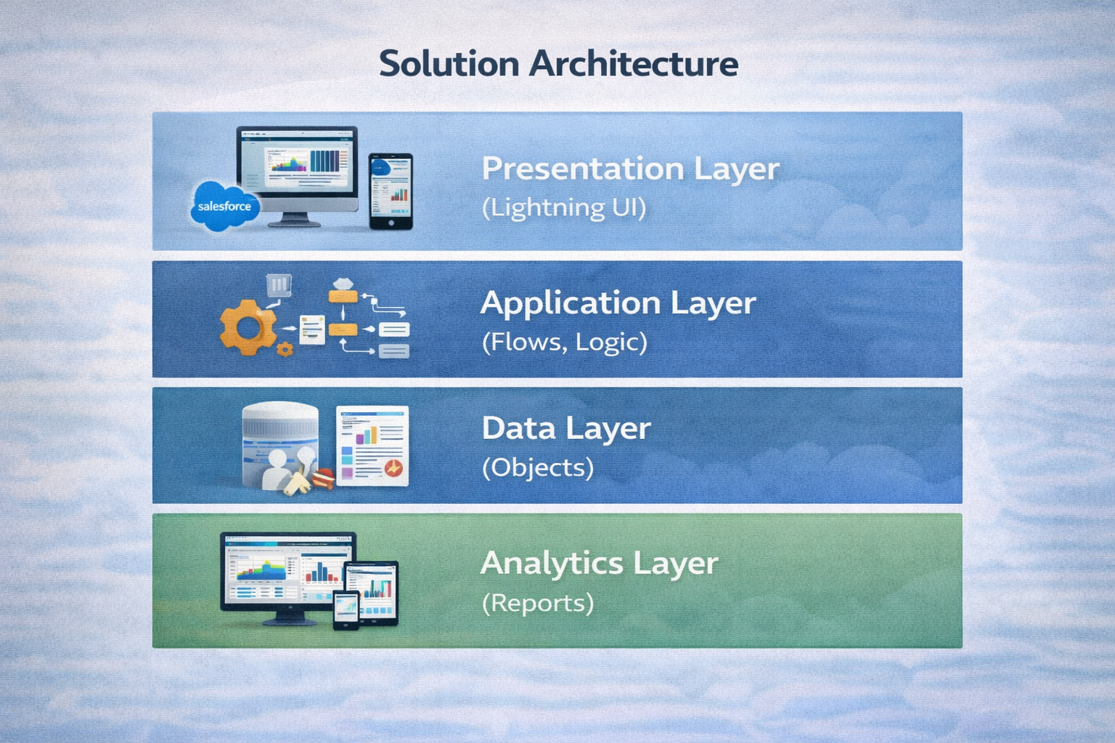

5. Design Flow
User Interface → Application Logic/Flows → Custom Objects & Relationships → Reports & Dashboards

6. Phase Conclusion
The design phase converts the identified requirements into a structured Salesforce solution using Lightning UI, flows, custom objects, relationships, roll-up summaries and analytics.

